Question:
Find the approximate solution of an ODE using Euler's Method using Python.
Aim:
Write a Python program to demonstrate to approximate y(x_target) for dy/dx = -y with y(0)=1 using Euler's method.
Program:
# euler_method.py
# Solve dy/dx = -y with y(0)=1 using Euler's method

def f(x, y):
"""The ODE: dy/dx = -y"""
return -y

def euler(x0, y0, h, x_target):
"""Euler's method to approximate y(x_target)"""
steps = int((x_target - x0) / h)
x = x0
y = y0
print("Step | x | y")
print("------------------")
print(f" 0 | {x:.2f} | {y:.6f}")
for i in range(1, steps + 1):
y = y + h * f(x, y) # Euler formula
x = x + h
print(f"{i:3d} | {x:2.2f} | {y:.6f}")
return y

if __name__ == "__main__":
# initial values
x0 = 0.0
y0 = 1.0
h = 0.01
x_target = 0.04

result = euler(x0, y0, h, x_target)
print("\nApproximate value at x=0.04:", round(result, 6))
Result:
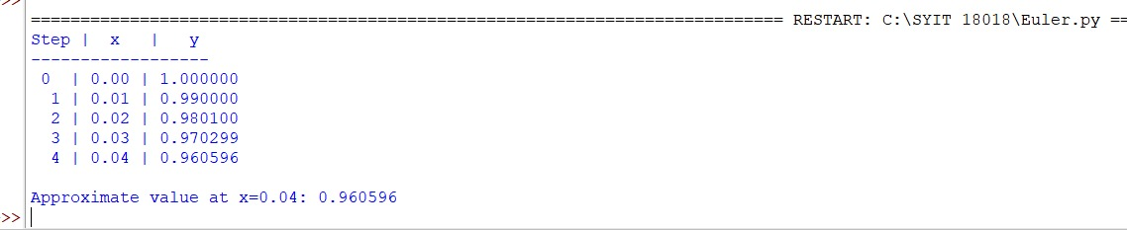

Conclusion:
The above Python program has been executed successfully.

